

**UNIVERSITY OF GHANA**

(All rights reserved)

**B.SC INFORMATION TECHNOLOGY, SECOND SEMESTER EXAMINATIONS: 2015/2016**

CSIT 208: MULTIMEDIA AND WEB DESIGN (3 CREDITS)

**INSTRUCTION:**

***Answer ALL Questions in Section A and any THREE Questions in Section B***

***Students are Advised to Spend Ten Minutes Reading and Planning***

**Answer ALL questions in Section A and any THREE questions in Section B**

**TIME ALLOWED:**

*TWO AND A HALF (2½) HOURS*

**SECTION A**

**Compulsory – Answer *all* questions**

(Total marks for this section is 40)

A1.

1. Design a webpage with the interface below. Use HTML, JavaScript and CSS where necessary to design both the interface and functionality. After the user enters values of A, B and C, the root should be calculated using the formula provided and displayed in the textbox. It should also notify the user whether the equation has a equal, unequal or complex roots. (*Hint: The equation is an image embedded in the page*)

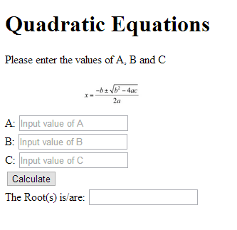

**(20 marks)**

1. 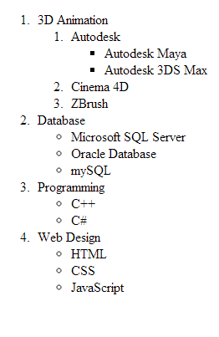Write HTML codes behind the list below.

**(10 marks)**

1. Distinguish between block elements and in-line elements **(4 marks)**
2. List the six criteria for the classification of a medium  **(6 marks)**

**SECTION B**

**Answer any THREE questions**

(Total marks for this section is 60)

B1.

1. An HTML page has the interface below. The first, second and third textboxes have IDs of “first”, “second” and “third” respectively and the buttons have “sum”, “avg” and “max” has IDs respectively

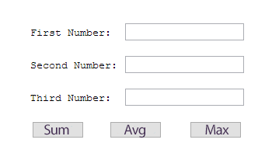

* 1. Write a JavaScript function that finds the sum of all three numbers and displays it as an alert
  2. Write a JavaScript function that finds the average of all three numbers and displays it as an alert
  3. Write a JavaScript function that finds the largest of the three numbers and displays it as an alert

**(10 marks)**

1. Write an HTML code to import a CSS file (main.css) into an HTML document

**(5 marks)**

1. Write the basic structure of an HTML document with linked JavaScript and CSS files  **(5 marks)**

B2.

1. What are the differences between HTML, CSS and JavaScript and how do they fit into web design?

**(4 marks)**

1. An image with class name “icon” is embedded into a web page. Write a CSS code that gives it the following properties:
   1. a solid, orange, 10px border
   2. 30px left and right padding
   3. 50px top and bottom margin

**(6 marks)**

1. What will be displayed in the browser when this code runs?

<!doctype html>

<html>

<head>

<title>My Test</title>

<script type= "text/javascript">

var myobj = {fname: "Joseph", mname:"Kwesi", lname:"Aquah", height:"7\"1' ", weight:"54 kg"};

document.write("<table border = \" 1 \" style = \" width:50% \" ><tr>");

for (x in myobj ){

document.write("<td>"+myobj[x]+"</td>");

}

document.write("</table></tr>");

</script>

</head>

<body>

</body>

</html>

**(10marks)**

B3.

1. What is a DOM? **(1 mark)**
2. Using an event handler, write JavaScript code that alerts the user when he clicks on a button. (*Hint: show both HTML and CSS codes for the button*)

**(4 marks)**

1. List five methods of the document object

**(5 marks)**

1. Create an array using HTML and JavaScript with fives elements. Using loop, display the contents of this array to the browser

**(10 marks)**

B4.

* + 1. Draw the DOM tree of the HTML document below (**20 marks)**

